­­­­****

**SOCIAL CONNECT AND RESPONSIBILITY (BSCK307)**

**MODULE 5**

**AAHARA MELA**

***The main objective of this aahara mela is to experience the cultural and richness of the food across India. It helps in the deeper understanding of cultural food of India.***

**NAME OF THE STUDENT : VISHWAS S**

**USN NO : 1VI22CS125**

**SEM / SEC : 3rd SEM / B SEC**

**NAME OF THE FACULTY MENTOR : Mr.GOPAL KRISHNA**

**AGENDA**

* **Introduction**
* **Theme of each department with food**
* **Favourite food in the mela**
* **Image gallery**

1. **INTRODUCTION**

A food walk typically refers to a guided tour or excursion where participants can explore different food. It's a unique way to experience local cuisine, try new dishes, and learn about the culinary culture of a place. It's like a adventure filled with delicious food and interestingstories behind each dish. So, a title like "Food Walk" suggests an event or activity centered around exploring and enjoying the diverse food. Its a great way to discover hidden culinary gems and satisfy your taste buds.

As we are aware that year ‘2023’ is declared as the international Millet Year by United Nations General Assembly. It was declared to highlight the importance of millets in addressing global challenges like hunger malnutrition, and climate change. Millets are highly nutritious and resilient crops, making them valuable for food security and sustainable agriculture. The declaration of International Millet Year aims to bring attention to these benefits and encourage their cultivation and consumption worldwide.Considering the celebration of international millet year 2023 "we have arranged a "AAHARA MELA" where we had a intra state cuisine on 27th Dec 2023.

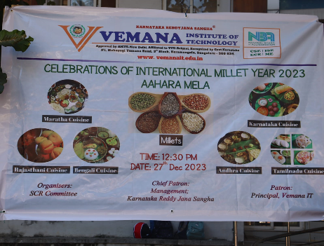 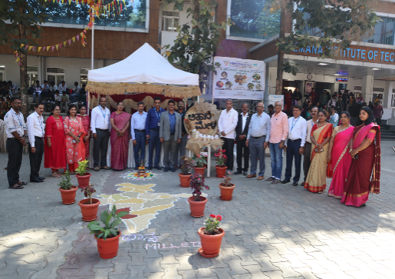

Figure-5.1 Figure -5.2

**2.THEME OF EACH DEPARTMENT**

Each department has actively participated in the event , each department represented different state cuisine,department of electronic and communication engineering: karnataka cuisine, department of computer science engineering: maratha cuisine, department of information science engineering: rajasthani cuisine, department of aiml engineering : bengali cuisine, department of basic science engineering : andhraPradesh, department of civil / mechanical engineering: tamilnadu cuisine. Dance forms of each state Maratha dance is known as "Lavani", Rajasthan has "Ghoomar" and "kathak", Andhra has "kuchipudi", Karnataka has "Yakshagana",Tamil Nadu has "Bharatanatyam",West Bengal has "Gaudiya Nritya".

**2.1 DEPARTMENT OF ELECTRONIC AND COMMUNICATION ENGINEERING: *Karnataka Cuisine***

Electronic and communication department has got Karnataka state. Karnataka is known for its rich cultural heritage, ancient temples like the famous. Mysore Palace and hampi, the beautiful hill stations of coorg and chikmagalur, and its delicious cuisine, induding the mouth watering masala dosa and filter coffee.Karnataka is also home to the IT hub of India, Bangalore which is known for its vibrant tech industry.

Menu:

* Naati Done Biryani
* Mudde with naati kali saaru
* Roti with Yenne Gayi Palya
* Mirchi mandakki
* Mysore Paak
* Majjige

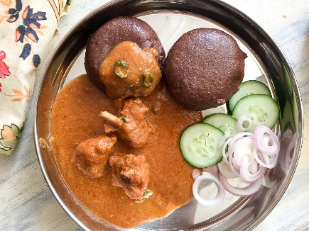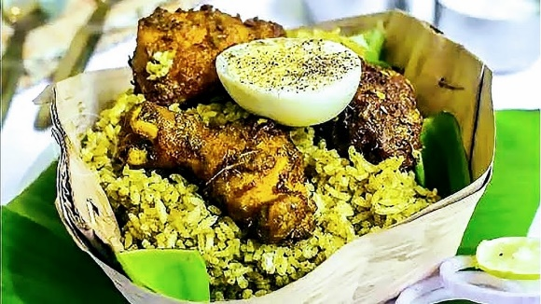

Figure-5.3Naati Done Biryani Figure-5.4 Mudde with naati kali saaru

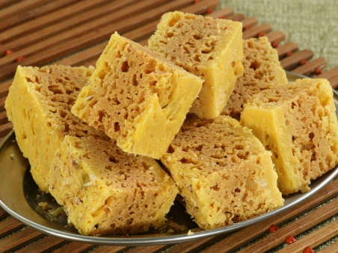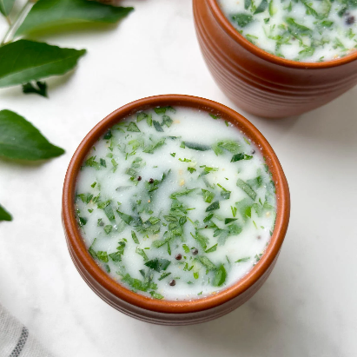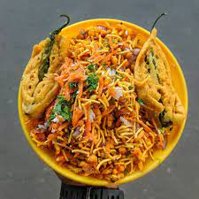

Figure-5.5Mirchi mandakki Figure-5.6 Mysore Paak Figure5.7Majjig

**2.2DEPARTMENT OF COMPUTER SCIENCE ENGINEERING: *Maratha Cuisine***

Maharashtra is a vibrant state in western India known for its rich culture, diverse landscapes,

delicious cuisine, and contributions to literature and cinema. From bustling cities like

Mumbai to serene hill stations, Maharashtra offers a diverse and exciting experience. Its

cuisine, festivals, and historical sites add to its charm. It's a place where you can immerse

yourself in the beauty of the Western Ghats, enjoy flavorful dishes like Vada Pav and Pav

Bhaji, and witness the vibrant cultural heritage of the Marathas.

Menu:

* Starters - Darbari Kebab
* Kolhapuri fish fry
* Drinks -Grape pulp
* Charts-Vada pav, pav bhaji, Dahi puri and sev puri.

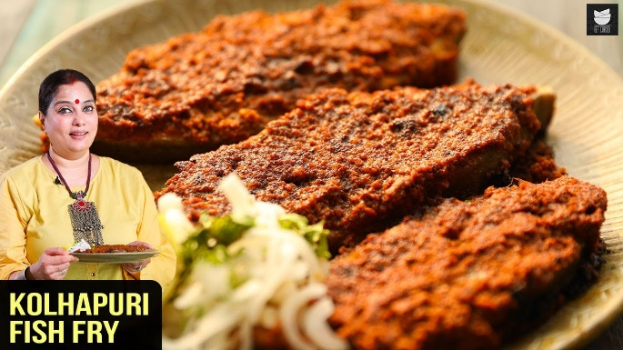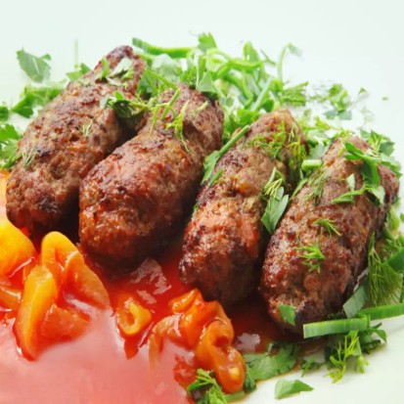

Figure-5.8 Darbari Kebab Figure-5.9 Kolhapuri fish fry

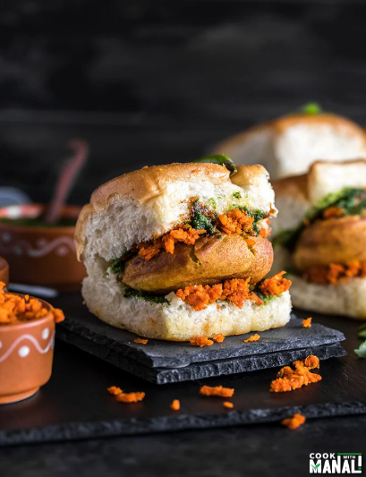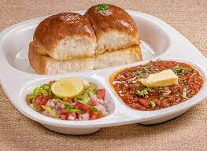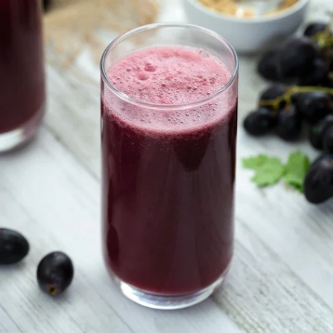

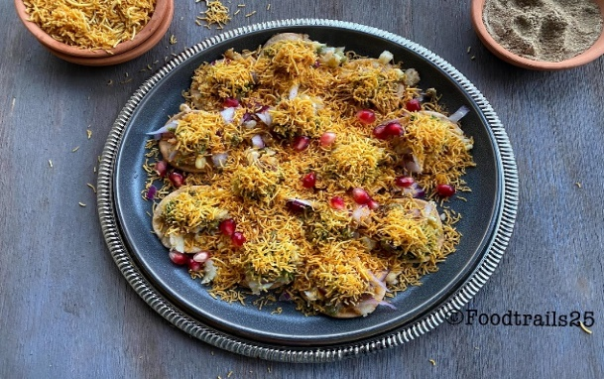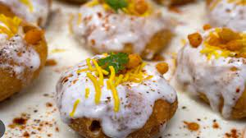Figure-5.10 Grape pulp Figure-5.11 Vada pav Figure-5.12 Pav bhaji

Figure-5.13 Dahi puri Figure-5.14 Sev puri

**2.3 DEPARTMENT OF INFORMATION SCIENCE ENGINEERING:*Rajasthani Cuisine***

Rajasthan is famous for its rich history, majestic forts and palaces, vibrant culture and colourful festivals like the Pushkar Camel Fair and the Jaipur Literature Festival. Rajasthan is delightful! It's known for its rich and flavorful dishes. some popular dishes include Dal Baati Churma, gatte ki sabzi, Laal Maas and karsangri. The cuisine is often characterized by its generous use of spices and ghee, which gives it a unique and delicious taste. It is also known for its traditional art and craft forms like bandhani, block printing, and miniature paintings. The thar Desert with its sand dunes and camel safaris, is another iconic feature of Rajasthan.

Menu:

* Thali, Rumali roti with panner curry
* Sweet lassi, Khara lassi
* Rajasthani biryani
* Dahi kachori, Plain kachori
* Rasgulla, jalebi

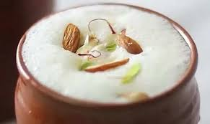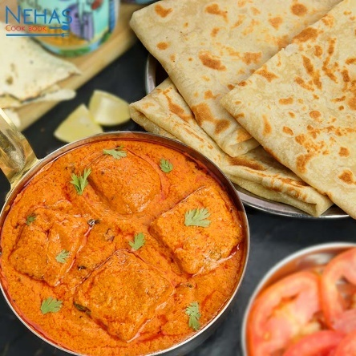

Figure-5.15 Rumali roti with panner curry Figure-5.16 Sweet lassi, Khara lassi

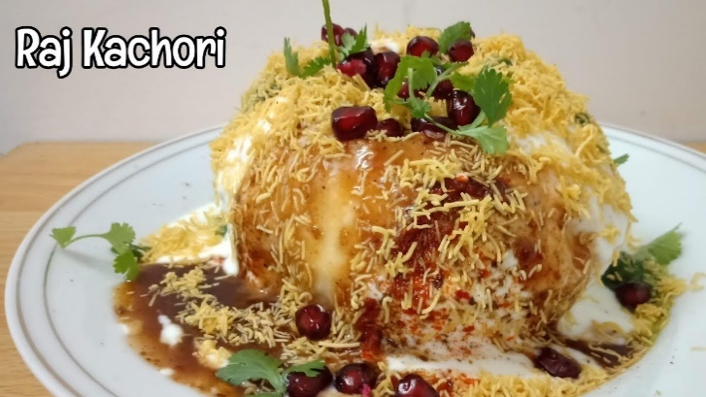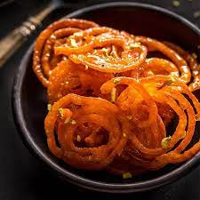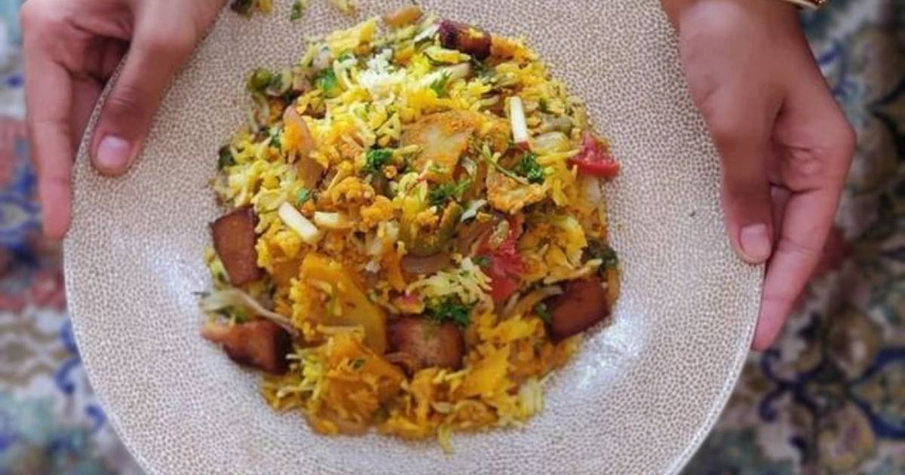

Figure-5.17Rajasthani biryani Figure-5.18 Dahi kachori Figure-5.19 Jalebi

**2.4 DEPARTMENT OF AIML ENGINEERING :*Bengali Cuisine***

The state has a rich literary heritage and has produced renowned writers and poets like Rabindranath Tagore and Satyajit Ray. Kolkata, the capital city, is known for its intellectual and artistic pursuits. The people of West Bengal are known for their love for music, dance, and theatre. The state is also famous for its handloom and handicraft products, such as the exquisite Baluchari and Kantha sarees. The natural beauty of West Bengal is also worth exploring, with places like Darjeeling and the tea gardens of the Dooars region offering breathtaking views. West Bengal is a vibrant state in eastern India known for its rich culture, literature, art, and delicious cuisine. The capital city is Kolkata, and it's famous for festivals like Durga Puja. The cuisine is mouthwatering, with dishes like MachherJhol and Mishti Doi. The state is also home to the Sunderbans, the largest mangrove forest in the world.

Menu:

* Rasgulla
* Puchka
* Kolkata Biriyani
* Macha poda
* 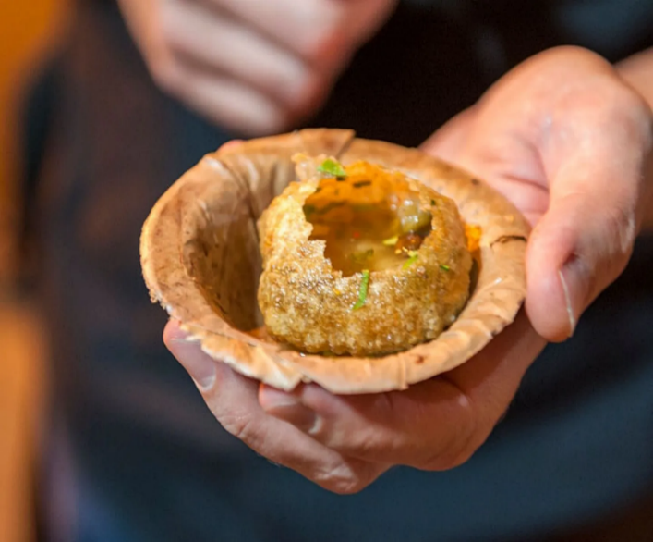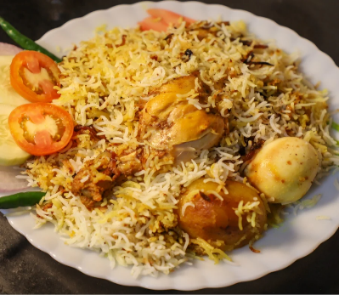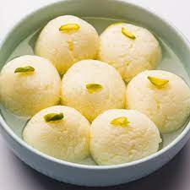Rasmilai

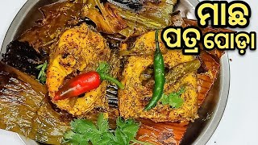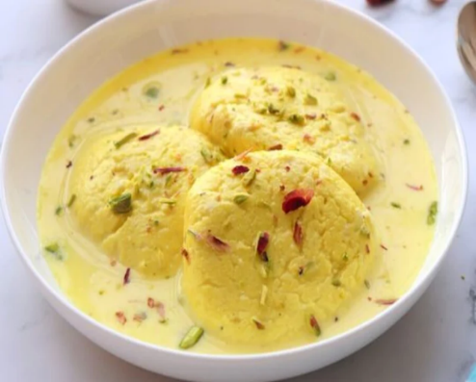 Figure-5.20 Rasgulla Figure-5.21 Kolkata Biriyan Figure-5.22 Puchka

Figure-5.23 Macha poda Figure-5.24Rasmilai

**2.5 DEPARTMENT OF BASIC SCIENCEENGINEERING :*Andhra Pradesh***

Andhra Pradesh is famous for its rich cultural heritage and mouthwatering cusine. The state is known for its spicy and flavorful dishes like Hyderabadi Biryani, gonguraPachadi, and Pesarattu. Andhra is also home to many beautiful temples, including the famous Tirupati Balaji temple. The state has a vibrant arts scene, with kuchipudi dance and carnatic music being popular forms of expression.

Menu

* Hyderabadi Biryani
* Chilli chicken
* Veg biryani
* Gobi 65
* Cut mirchi
* Glan halwa
* 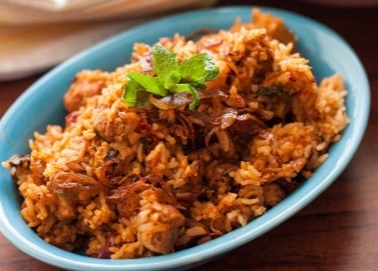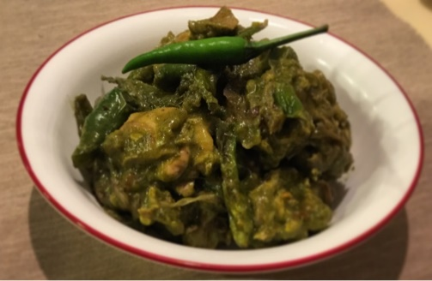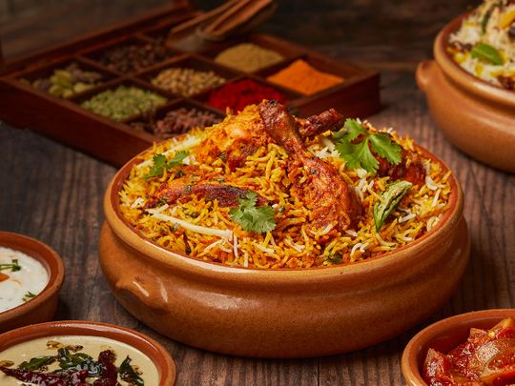Kushka

Figure-5.25 Hyderabadi Biryani Figure-5.26 Chilli chicken Figure-5.27Veg biryani

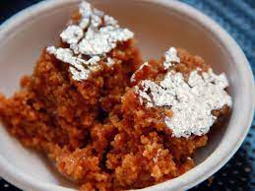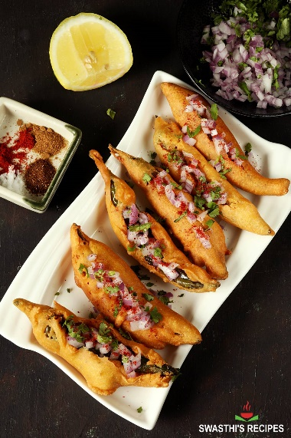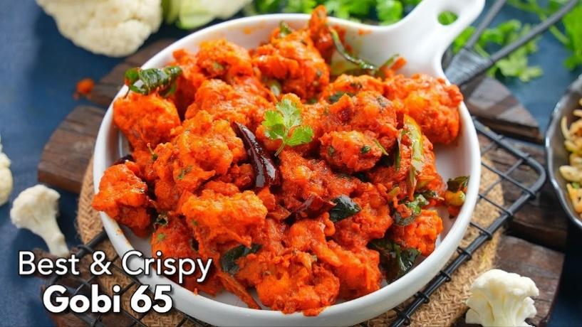

Figure-5.28Gobi 65 Figure-5.29 Cut mirchi Figure-5.30Glan halwa

* 1. **DEPARTMENT OF CIVIL / MECHANICAL ENGINEERING: *Tamil Nadu Cuisine***

Tamil Nadu as it is often called, is famous for its rich cultural heritage, ancient temples, and classical arts. The state is known for its beautiful temples. like the Meenakshi Amman temples in Madurai and the Brihaduswarar Temple in Thanjavur. Tamil Nadu is also renowned for its traditional music and dance form like Bharatanatyam. The cuisine of tamil Nadu, with its delicious dosas, idlis, and sambar, is loved by people all over the country.

Menu:

* Ambur biryani and kabab
* Parotta and chicken gravy and dal tadka
* Biriyani ,chettinad chicken
* 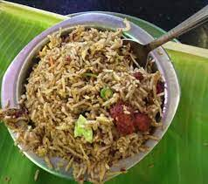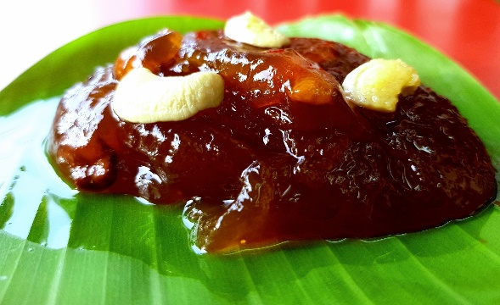Tirunelveli halwa

Figure-5.31Ambur biryani and kabab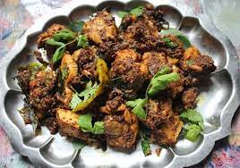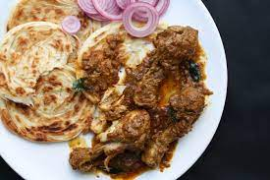 Figure-5.32Chicken Tirunelveli halwa

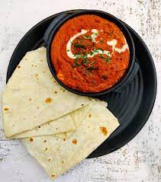 Figure-5.33 Parotta and chicken gravy Figure-5.34 ChettinadChicken

**3.FAVOURITE FOOD IN THE MELA**

Figure-5.35 Rumali roti with panner curry

My favourite food in the mela was Rumali roti with panner curry.

**3.1 INGREDIENTS USED**

For Rumali Roti:

- 2 cups of wheat flour

- 1 tablespoon of oil

- A pinch of salt

- Water for kneading the dough

For Paneer Curry:

- 200 grams of paneer (cottage cheese), cut into cubes

- 2 onions, finely chopped

- 2 tomatoes, pureed or finely chopped

- 1 tablespoon of ginger-garlic paste

- 1 teaspoon of cumin seeds

- Spices: 1/2 teaspoon of turmeric powder, 1 teaspoon of red chili powder, 1 teaspoon of garam masala

- Salt to taste

- Oil for cooking

- Fresh coriander leaves for garnishing

**3.2 RECIPE**

For Rumali Roti:

1. In a mixing bowl, combine 2 cups of wheat flour, 1 tablespoon of oil, and a pinch of salt.

2. Gradually add water and knead the dough until it becomes soft and pliable.

3. Divide the dough into small balls and roll them into thin, translucent rotis.

4. Heat a tawa or griddle and cook the rotis on both sides until they puff up and get light brown spots.

5. Serve hot with Paneer Curry.

For Paneer Curry:

1. Heat oil in a pan and add cumin seeds, chopped onions, and ginger-garlic paste. Sauté until onions turn golden brown.

2. Add chopped tomatoes and cook until they become soft and mushy.

3. Add spices like turmeric powder, red chili powder, garam masala, and salt. Mix well.

4. Add paneer cubes and cook for a few minutes until the paneer absorbs the flavors of the spices.

5. Finally, add a little water to adjust the consistency of the curry and let it simmer for a few more minutes.

6. Garnish with fresh coriander leaves and serve hot with Rumali Roti.

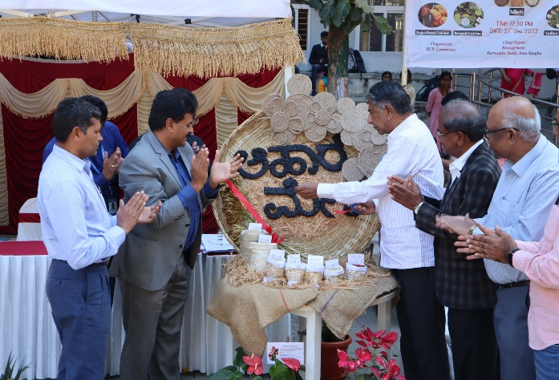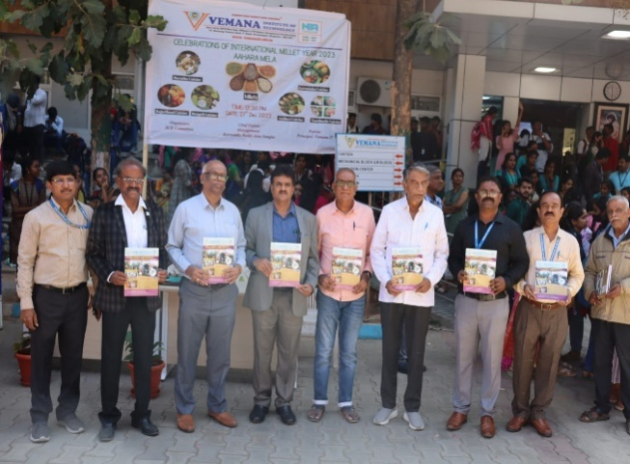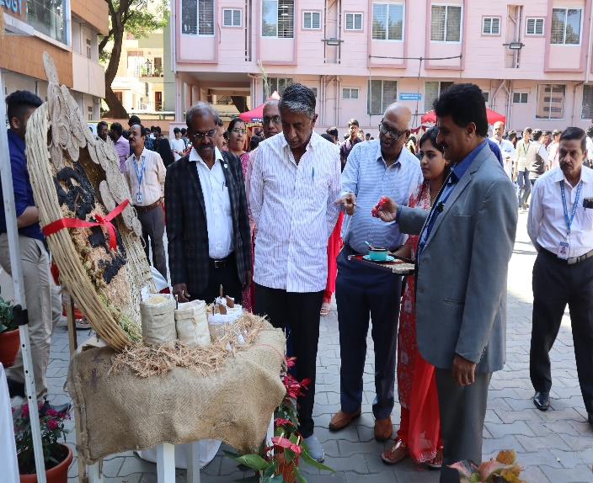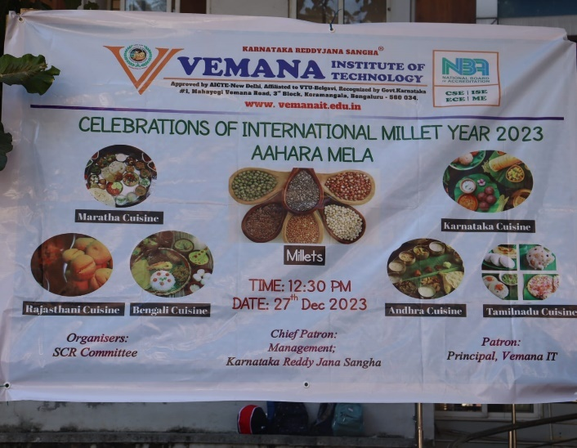**4.IMAGE GALLERY**

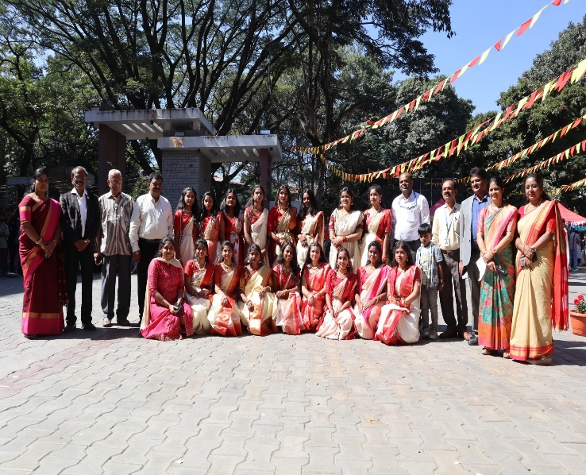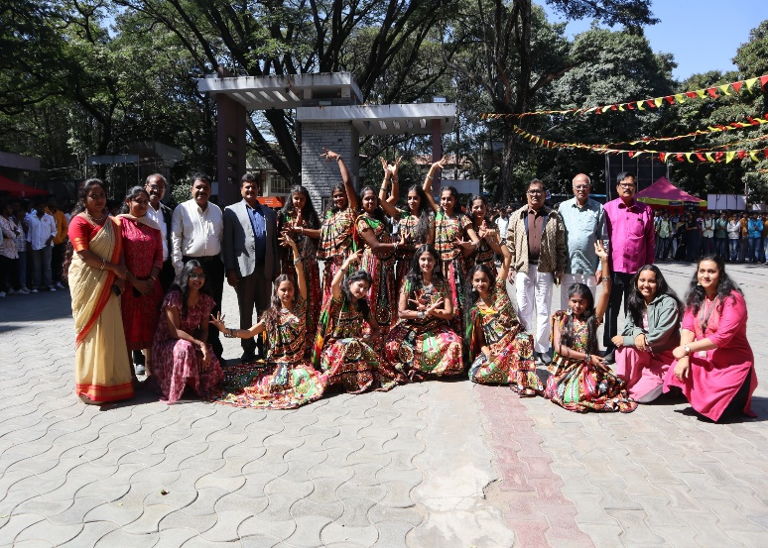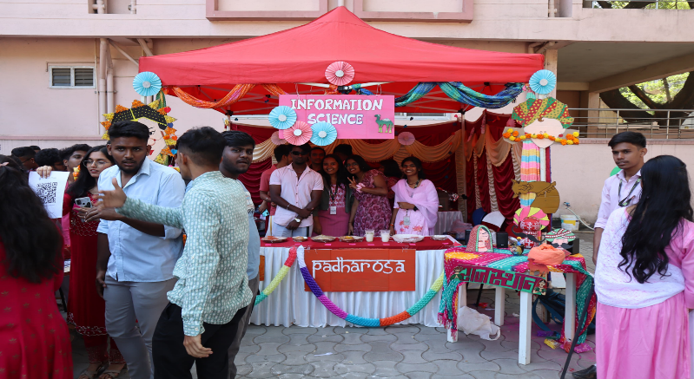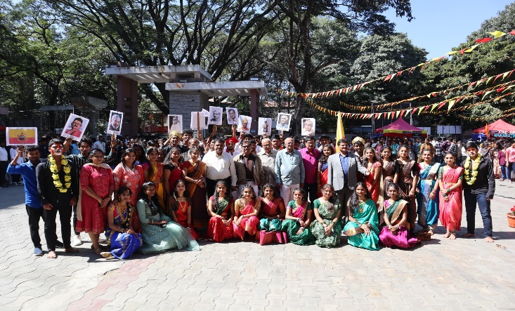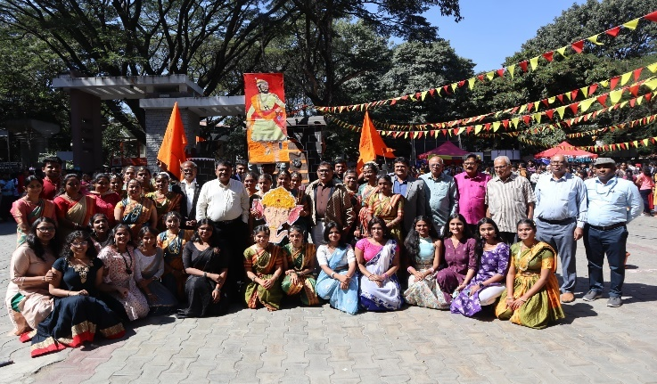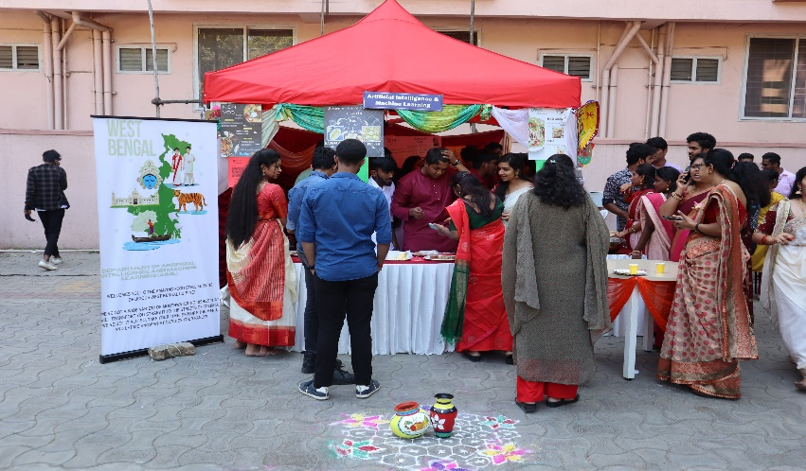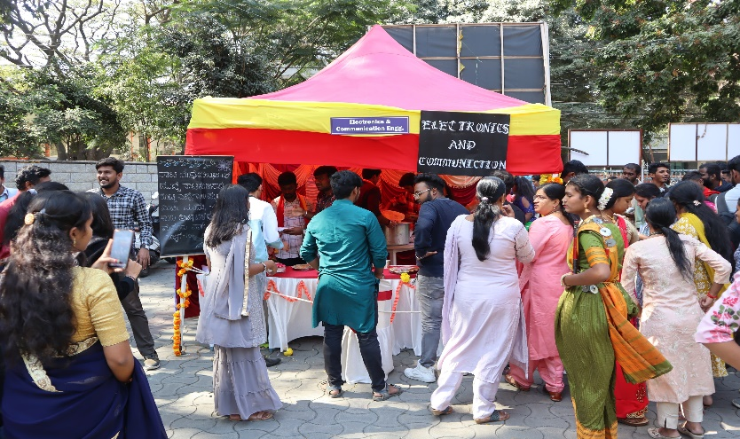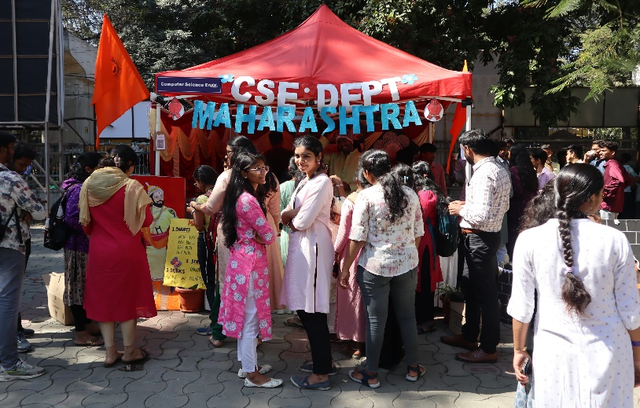

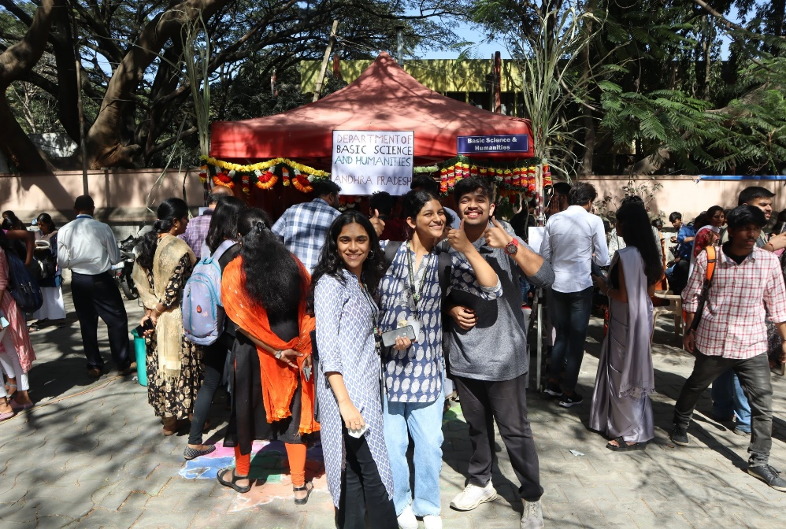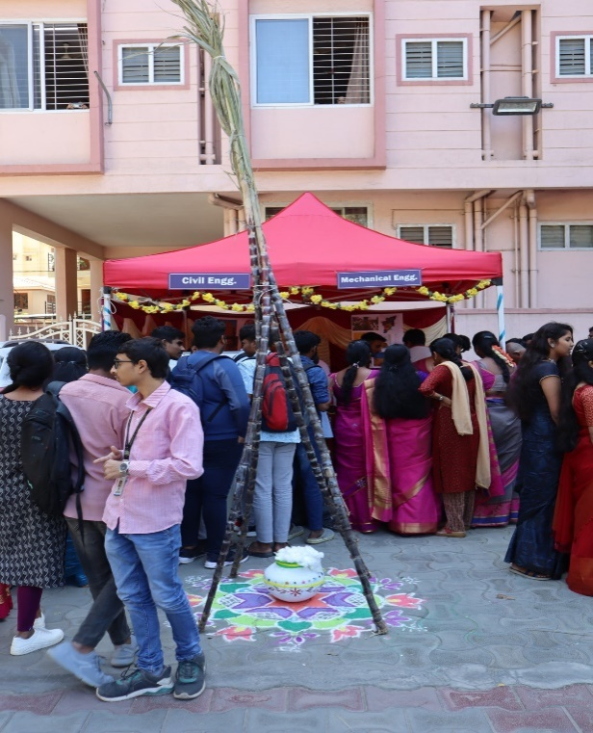

**Dated:- 27th December 2023 Student Signature:-**

**Report Prepared On:-11th March 2024 Mentor Signature:-**